**ARTHIST 390S: Gentrification and the Urban Landscape**

Bacca Faculty Fellows are a small cohort of faculty (all ranks eligible) who commit to trying new methods or approaches in one of their courses. Following is Annabel Wharton’s reflection on the work on her Gentrification and the Urban Landscape course undertaken as a Bacca Fellow.

Annabel Wharton

William B. Hamilton Distinguished Professor of Art and Art History

Bacca Fellowship Statement, April 14, 2022

To teach is to learn.

Duke – both the University and my Department – has always been good about letting me teach what I want to teach. Certainly, there were curricularly required courses that I regularly volunteered to offer, but even those always complemented my intellectual interests. My own courses, both graduate and undergraduate, have all inevitably engaged my research. Like most faculty, I have taught what I know – medieval and modern architectures and urbanisms, objects and sites of pilgrimage and tourism, theory. This semester, in contrast, I’m teaching a subject about which I know very little: gentrification.

Black Lives Matter and the rising threat of fascism in this country destabilized my complacently liberal assumptions about my immediate environment. And, proverbially, the best way to learn about something is to teach it. The process of constructing and producing this class has, indeed, proved extraordinarily rewarding for me (and I hope for my students). I was aided in this process by the BACCA seminar and, perhaps even more so, by meetings and discussions of pedagogical as well as intellectual issues with my colleagues in the Mellon-funded Visualizing Cities initiative.

I experimented with my teaching. I articulated the objectives for this course differently than I had previously, acknowledging that the goals of the course were set not just for my students, but also for myself.

**Objectives of the professor and her students**

Acquire an understanding of how built spaces inform the lives of those who occupy them.

Nurture the habit of always questioning assumptions, both your own and those of others. Or, put another way, acknowledge your own ignorance and recognize it in your interlocutors.

Work (struggle) to improve oral and particularly written communication of complex ideas.

Integrate questions and answers from elsewhere (other courses, news, daily experience) into thinking through the current or historical issues being confronted.

Embrace difference; recognize that difference may involve historical inequity.

More practically, I deployed new teaching tactics. These included:

1. Appointing a weekly honorary TAs. As the course is an undergraduate seminar, without a graduate TA, I appointed, in alphabetical order, TAs from the members of the class. Their duties included the following (* on Zoom):

*Co-host

Arrive ten minutes early to help me arrange the seminar space

Take charge of any recording necessary for missing students (e.g. remind me to turn on and off the recorder on my phone)

Take attendance

*Watch for raised hands

*Monitor chat

Stay after to briefly assess the strengths and weaknesses of discussion; suggest improvements in the order or mode of presentation.

This practice was very useful in allowing me to get to know my students better. They consistently expressed a sense that this experiment in small authority increased their engagement in the course.

2. Prompts. As in the past, to avoid simple summaries of assigned readings, I provided prompts for their weekly responses. But this semester I also requested that, after writing their response to my prompt, that they develop a prompt of their own. These student-produced response proved positive stimulants to class discussions.

Example:

Readings: Michel de Certeau, *The Practice of Everyday Life*; Vanessa Mathews, “Aestheticizing Space: Art, Gentrification and the City.”

My prompt: Is the artist of Mathews’s text one of the walkers in de Certeau’s essay?

Student’s prompt: Mathews alludes to the tourism industry’s role in urban gentrification. In what ways does de Certeau’s essay corroborate the idea of cultural tourism, and in what ways does cultural tourism affect (negatively or positively) a city’s urban fabric?

3. Visitors. For the first time, I invited non-academic speakers to the class. The Black professionals who visited the class included:

J.T. Tabron, Durham County’s Assistant Register of Deeds, discussing racial covenants

Ava Brownlee, local Allstate Insurance Agency owner, retired, discussing the impact in the past of insurance agencies’ coverage decisions on Black home ownership and current changes in the industry to address racial bias.

Kimberly Williams, Right Time Realty Agency owner and board member of the Durham County Land Trust, discussing redlining and the land trust movement.

These presentations were enormously productive. The students *loved* the visitors; the visitors *loved* the students. And we all learned a great deal.

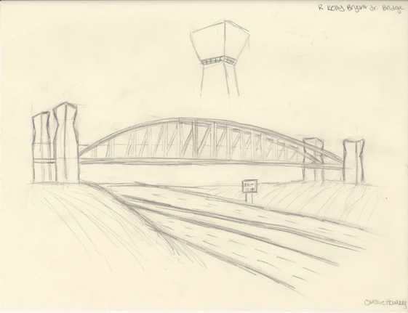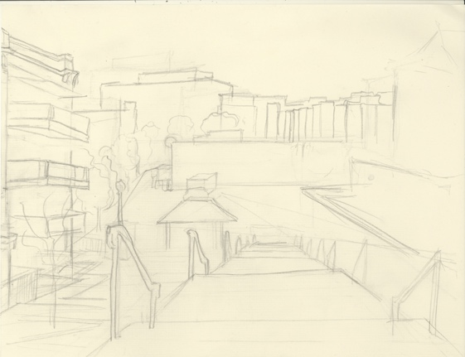

Caroline Howley, R. Kelly Bryant Pedestrian Bridge: urban walking and gentrification

Lindsay Hu, The Lofts at Southside: perplexities of low cost housing

4. Practicum: Drawing in the City (ungraded). Again for the first time, I attempted to integrate close looking, through drawing, into the broader understanding of the urban fabric.

This practicum was *not* about the sketch that is produced by drawing; it is about the *seeing and the visual memory* that is exercised and enabled by drawing. The time and place for the sketching practicum depended on the subject of a student’s project. Ideally, it was a 1½-hour session outside of class meetings, scheduled singularly or in small groups at times good for the instructor, the students, and the weather. These meetings also provided time for individual discussion with students about their particular sites.

The practicum was only partially successful. Illness, bad weather, and conflicts meant that I could only sketch with half of the students. But those students with whom I did have that time on site not only produced remarkable objects, but expressed their sense of the pleasure and intellectual profit of the experience.

In the end, the closer scrutiny of gentrification made me, and, I believe, my students not only sadder and angrier about the inequities imbedded in our community, but also able to see and articulate them more clearly. The course thus fulfilled its appropriate function.